**Practice Project 2**

**Validation of an Email ID**

**Sai Krishna Rajagopal**

**03-03-2022**

**GITHUB Repository URL:** [**https://github.com/SaiKrishna6699/CoreJavaTraining.git**](https://github.com/SaiKrishna6699/CoreJavaTraining.git)

**Technical Summary:**

1. **Java**
2. **Eclipse**
3. **Git**
4. **Java:**

The Validation of Email Id was developed in Java Programming Language using the concepts of Array List, Regex, Variables, Control Statements, Loops

* The Application is fully functional and working perfectly with No Exceptions

Short Summary of code:

* + The main class contains the Working of the application.
  + A static regex variable is declared for char @.
  + A Static Boolean method is initialized to compile and match the pattern in array items.
  + An Array list is initialized for taking Email Ids.
  + Email id will be stored into the Array list with the use of .add(System.in) to take user input.
  + Later the Array Email is iterated and checks whether the user input arrays are valid or not.
  + Finally, the result will be the output of the code.

1. **Eclipse:**

Eclipse is the IDE used to Write the code. It is a very programmer friendly and easy to use application.

1. **Git & GitHub:**
   1. Git is the version control system used to store the data in a remote Repository.
   2. GitHub is the remote data base contains repository which is used to store the data.

Git Commands used:

$git init

$git remote add origin “[**https://github.com/SaiKrishna6699/CoreJavaTraining.git**](https://github.com/SaiKrishna6699/CoreJavaTraining.git)”

$git remote -v

$git add .

$git commit -m “First Commit”

$git branch -M main

$git add Validating_Email_Id

$git push -u origin main

1. Screenshots:

Code:

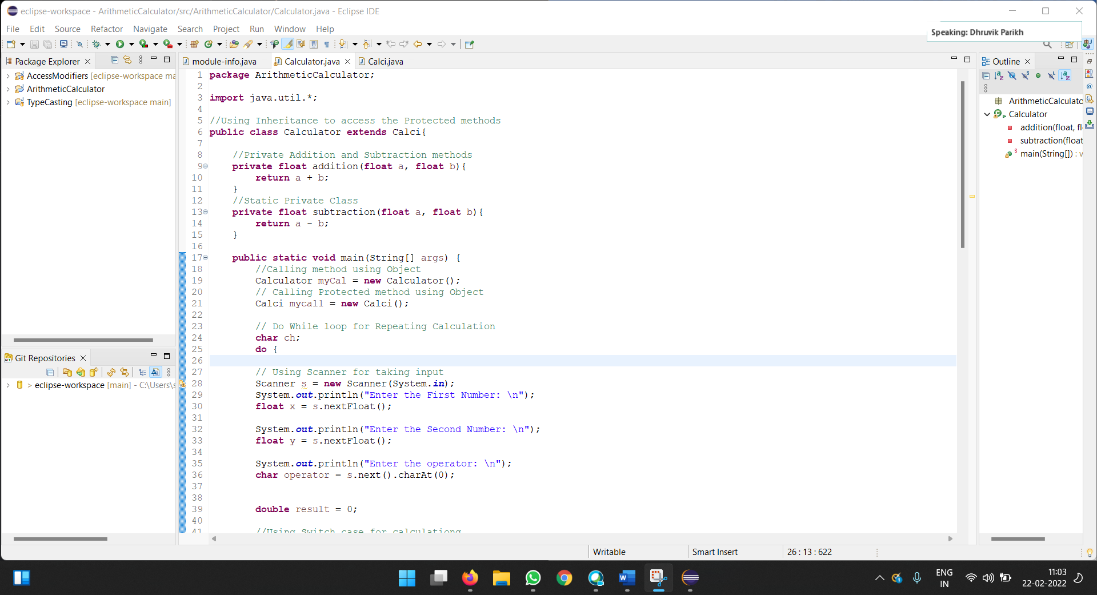

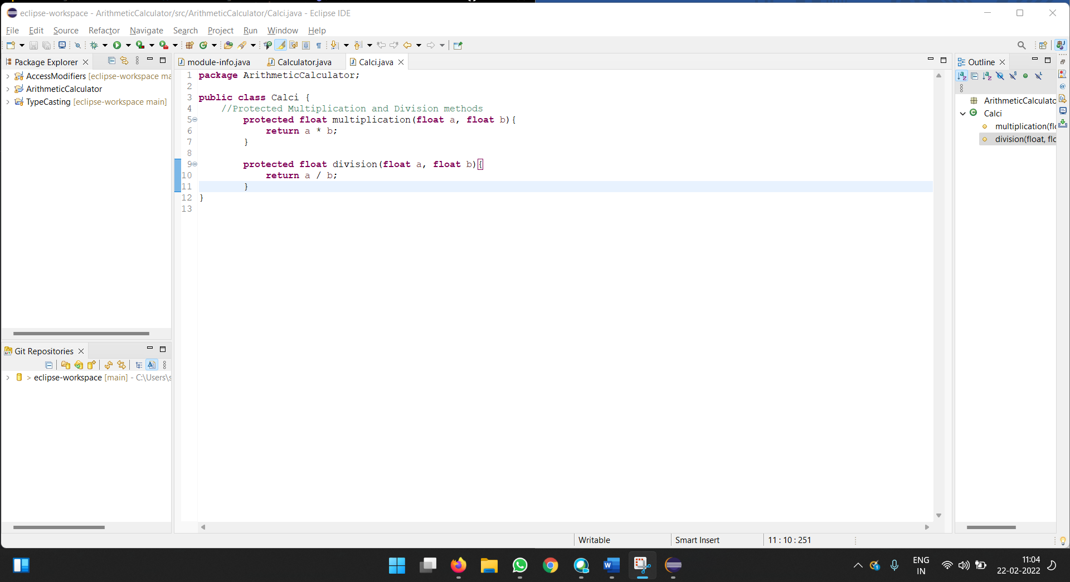

Output Sc shot:

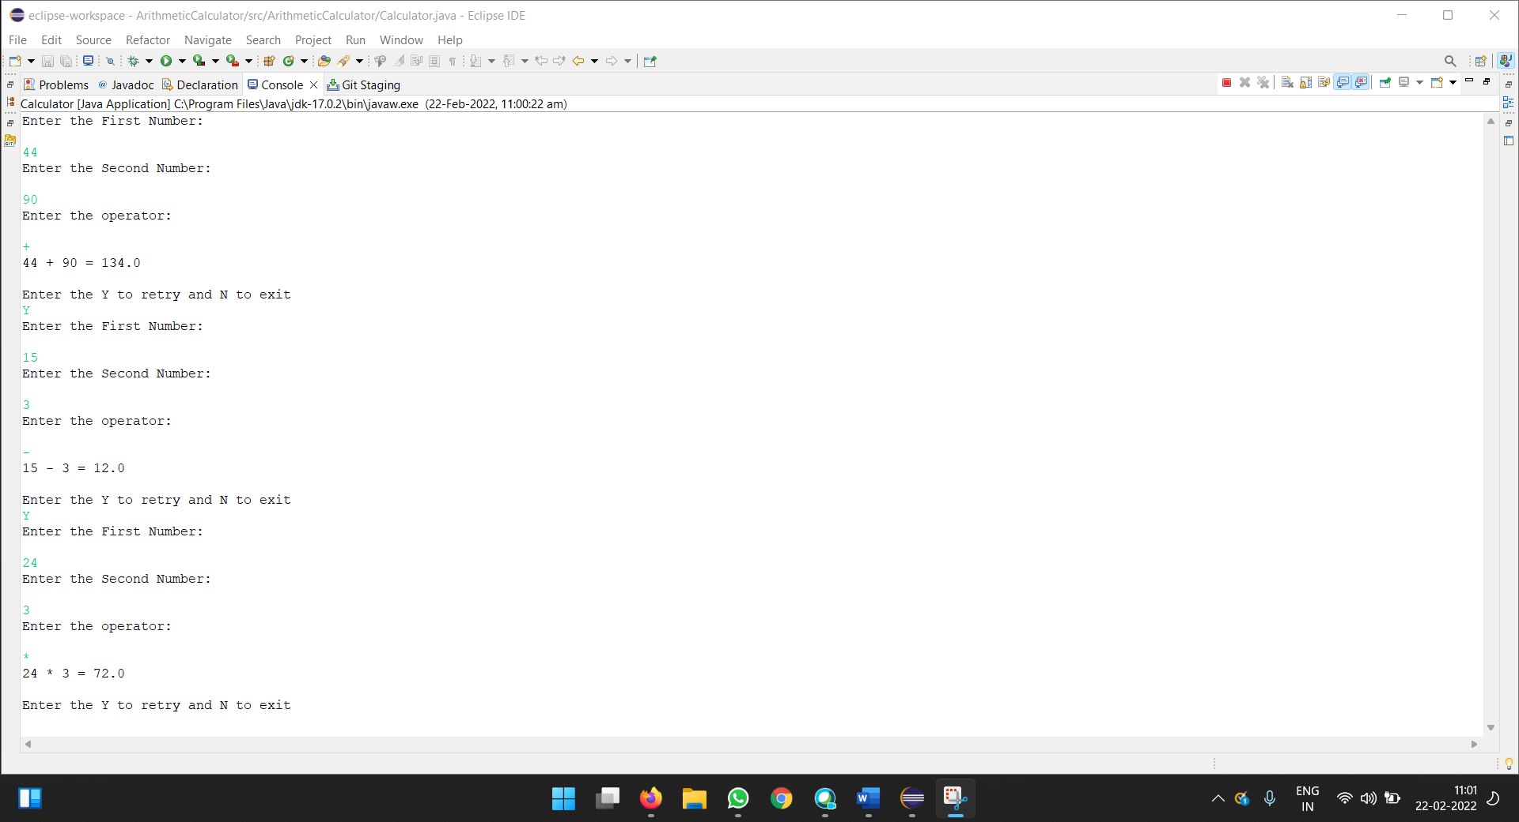

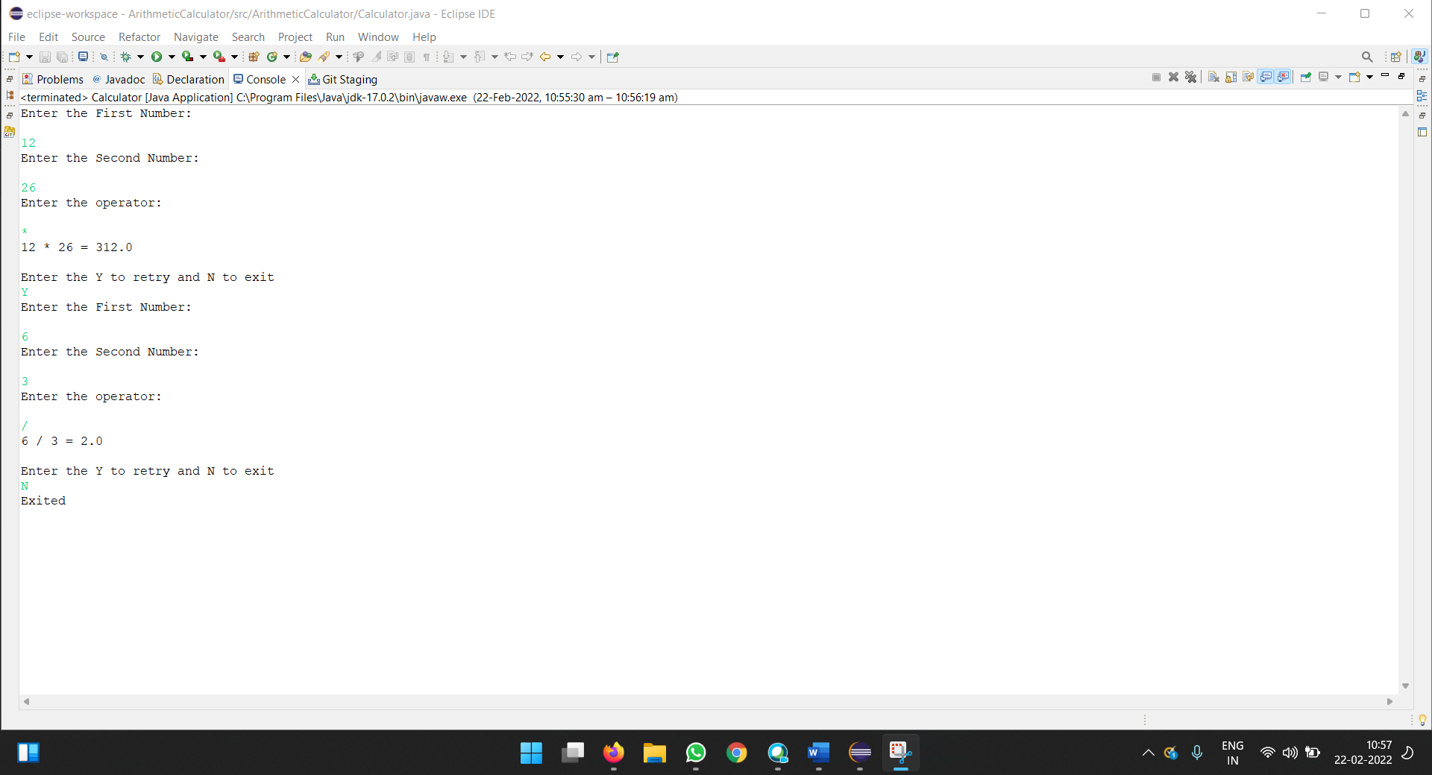

Git Commands:

